SQL GRANT OPTION
🔐 What is GRANT OPTION in SQL?
# Source: AI Source: Provided by: [Data Path: Persons Table -> ID Column: 1, Name_En Column: Motasem Essam] -> From: [ChatGPT] on [6/11/2026]
The GRANT OPTION is a special privilege in SQL that allows a user to grant privileges to other users.

📌 Without GRANT OPTION:
# Source: AI Source: Provided by: [Data Path: Persons Table -> ID Column: 1, Name_En Column: Motasem Essam] -> From: [ChatGPT] on [6/11/2026]
A user can use their privileges, but cannot give them to others.

📌 With GRANT OPTION:
# Source: AI Source: Provided by: [Data Path: Persons Table -> ID Column: 1, Name_En Column: Motasem Essam] -> From: [ChatGPT] on [6/11/2026]
The user can use their privileges and also share (grant) them to other users.

✅ Example:
# Source: AI Source: Provided by: [Data Path: Persons Table -> ID Column: 1, Name_En Column: Motasem Essam] -> From: [ChatGPT] on [6/11/2026]
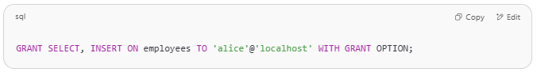
GRANT SELECT, INSERT ON employees TO 'alice'@'localhost' WITH GRANT OPTION;

- alice can now:
  - Read and insert into the employees table
  - Grant SELECT and INSERT on employees to other users

👎 Without WITH GRANT OPTION:
# Source: AI Source: Provided by: [Data Path: Persons Table -> ID Column: 1, Name_En Column: Motasem Essam] -> From: [ChatGPT] on [6/11/2026]
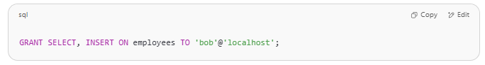
GRANT SELECT, INSERT ON employees TO 'bob'@'localhost';

- bob can read and insert.
- But cannot share these privileges with others.

🛑 Be Careful:
# Source: AI Source: Provided by: [Data Path: Persons Table -> ID Column: 1, Name_En Column: Motasem Essam] -> From: [ChatGPT] on [6/11/2026]
Granting GRANT OPTION gives power to spread permissions, so use it only for trusted users.

what privileges can granted by using when it GRANT OPTION
# Source: AI Source: Provided by: [Data Path: Persons Table -> ID Column: 1, Name_En Column: Motasem Essam] -> From: [ChatGPT] on [6/11/2026]
When a user is granted privileges with GRANT OPTION, they can grant only the privileges they themselves have to other users.

✅ What Privileges Can Be Granted with GRANT OPTION?
# Source: AI Source: Provided by: [Data Path: Persons Table -> ID Column: 1, Name_En Column: Motasem Essam] -> From: [ChatGPT] on [6/11/2026]
Any of the following standard privileges — if the user has them with GRANT OPTION:
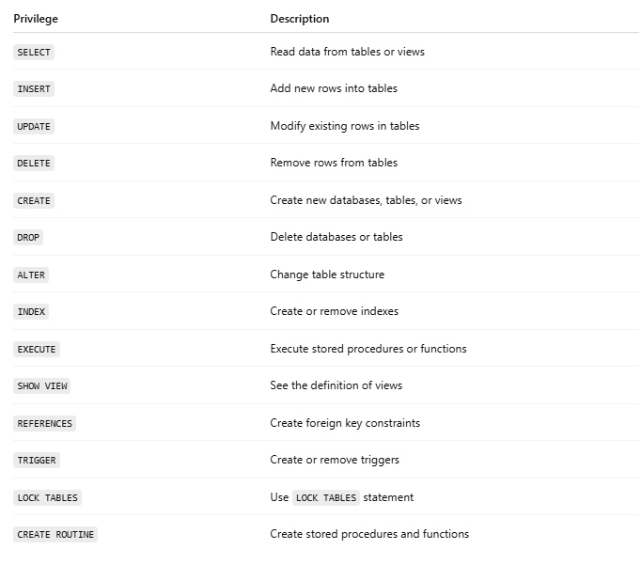
Privilege | Description
SELECT | Read data from tables or views
INSERT | Add new rows into tables
UPDATE | Modify existing rows in tables
DELETE | Remove rows from tables
CREATE | Create new databases, tables, or views
DROP | Delete databases or tables
ALTER | Change table structure
INDEX | Create or remove indexes
EXECUTE | Execute stored procedures or functions
SHOW VIEW | See the definition of views
REFERENCES | Create foreign key constraints
TRIGGER | Create or remove triggers
LOCK TABLES | Use LOCK TABLES statement
CREATE ROUTINE | Create stored procedures and functions

🔐 Example:
# Source: AI Source: Provided by: [Data Path: Persons Table -> ID Column: 1, Name_En Column: Motasem Essam] -> From: [ChatGPT] on [6/11/2026]
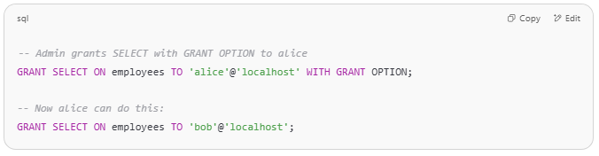
-- Admin grants SELECT with GRANT OPTION to alice
GRANT SELECT ON employees TO 'alice'@'localhost' WITH GRANT OPTION;

-- Now alice can do this:
GRANT SELECT ON employees TO 'bob'@'localhost';

But Alice cannot grant privileges she does not have. For example:
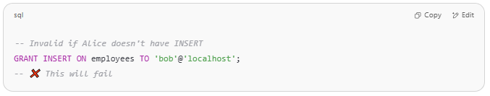
-- Invalid if Alice doesn't have INSERT
GRANT INSERT ON employees TO 'bob'@'localhost';
-- ❌ This will fail

🧠 Important Notes
# Source: AI Source: Provided by: [Data Path: Persons Table -> ID Column: 1, Name_En Column: Motasem Essam] -> From: [ChatGPT] on [6/11/2026]
- A user cannot grant more than they themselves have.
- The GRANT OPTION is tracked per privilege.
- Only a user with GRANT OPTION can further delegate.

Would you like a full demo scenario in MySQL to try this step by step?

Error GRANT OPTION;
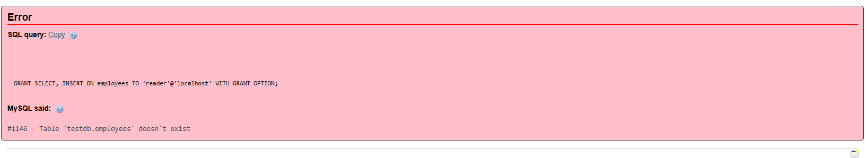
The error you're seeing:
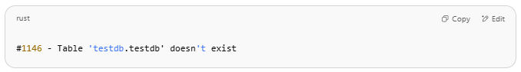
#1146 - Table 'testdb.testdb' doesn't exist

means that MySQL is trying to find a table named testdb inside a database also named testdb, but it doesn’t exist.

🔧 Why this happened:
You wrote:
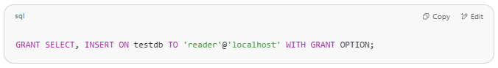
GRANT SELECT, INSERT ON testdb TO 'reader'@'localhost' WITH GRANT OPTION;

But in MySQL, this syntax:
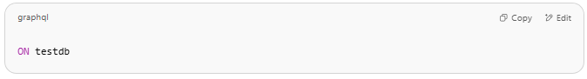
ON testdb

is interpreted as:
The testdb table in the currently selected database, or a table inside testdb named testdb.

✅ How to fix it:
You need to specify the database name and a valid table name, or use * to apply privileges to all tables in a database.

💡 Option 1: Grant on all tables in testdb
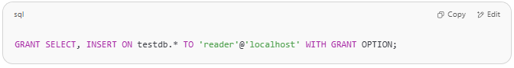
GRANT SELECT, INSERT ON testdb.* TO 'reader'@'localhost' WITH GRANT OPTION;

💡 Option 2: Grant on one table (example: customers)
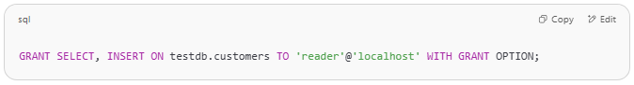
GRANT SELECT, INSERT ON testdb.customers TO 'reader'@'localhost' WITH GRANT OPTION;

🚨 Make sure:
- The database testdb exists
- The user reader@localhost exists (you can create it if not)
Let me know if you want a full working setup to test this with user creation and privilege assignment.

Example

prepared commands
# Source: ScreenShot Source: Provided by: [Persons Table -> ID Column: 1, Name_En Column: Motasem Essam] -> Tool: [Automation Table -> ID Column: 16, Name_En Column: Screen Capture] -> From [Operating System: Wampserver64 -> phpmyadmin] on [6/11/2026]
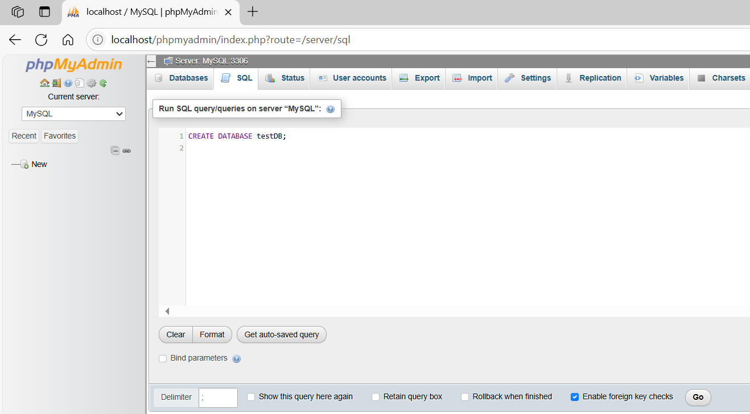
CREATE DATABASE testDB;
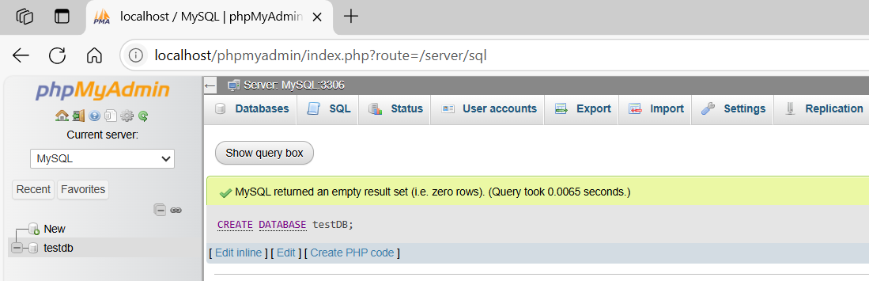
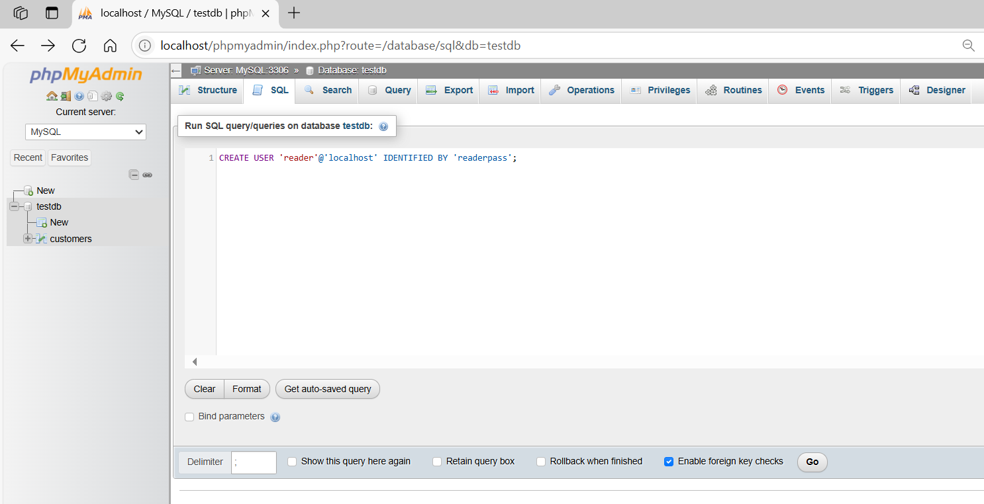
CREATE USER 'reader'@'localhost' IDENTIFIED BY 'readerpass';
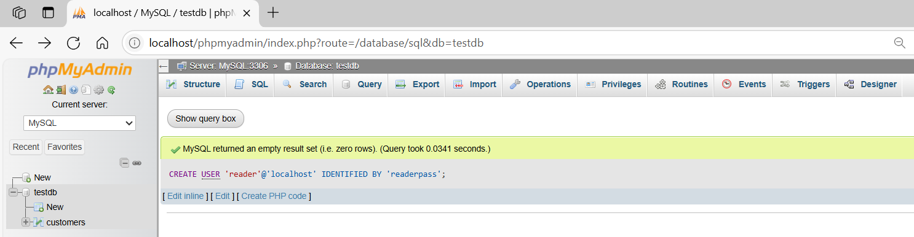

basic command
# Source: ScreenShot Source: Provided by: [Persons Table -> ID Column: 1, Name_En Column: Motasem Essam] -> Tool: [Automation Table -> ID Column: 16, Name_En Column: Screen Capture] -> From [Operating System: Wampserver64 -> phpmyadmin] on [6/11/2026]
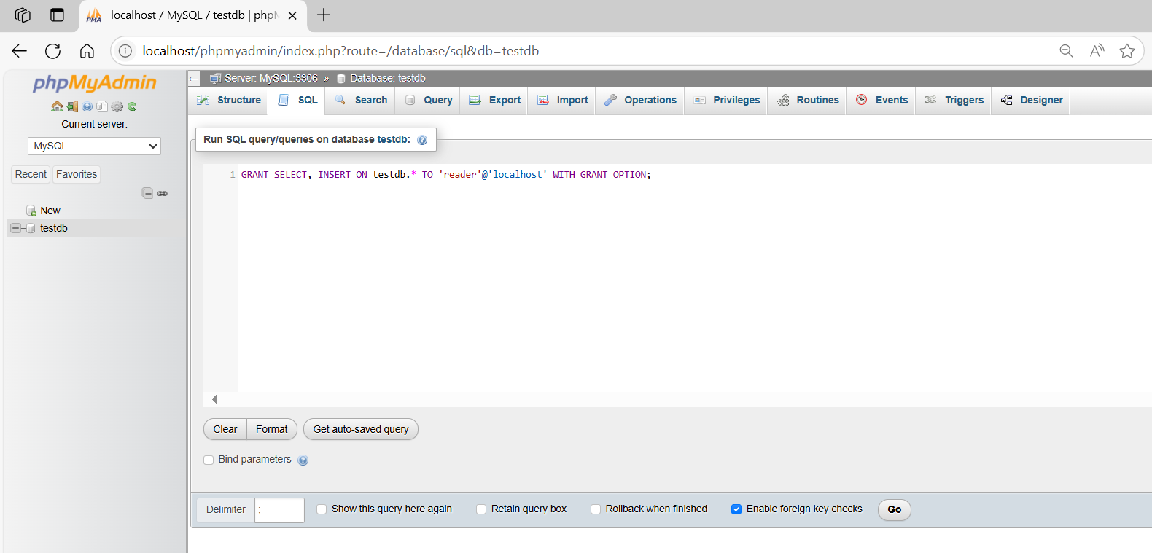
GRANT SELECT, INSERT ON testdb.* TO 'reader'@'localhost' WITH GRANT OPTION;
